****Welcome to Foundation Stage 2 (FS2)



We are really looking forward to meeting you and your child. we are looking forward to a wonderful year ahead!

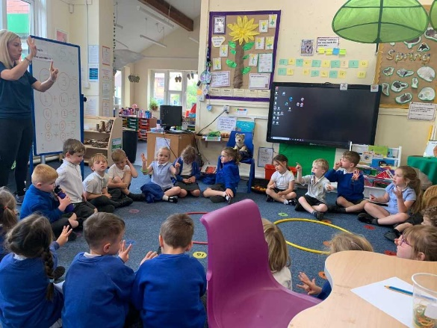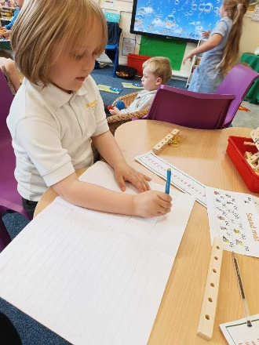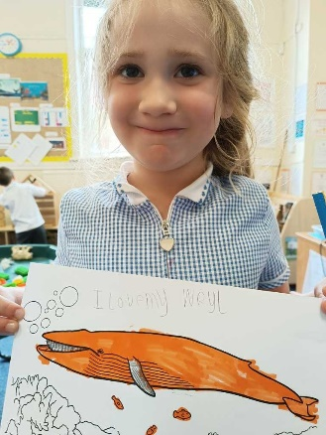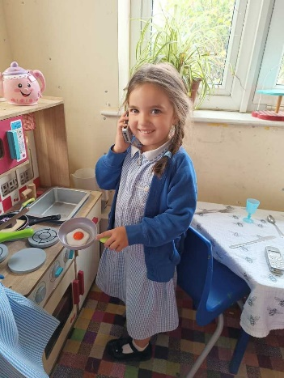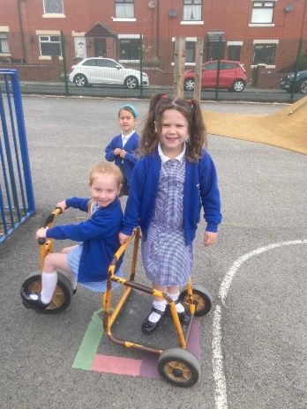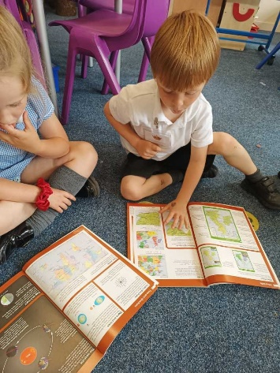

***“Play is the highest form of research” – Albert Einstein***

FS2 staff:

These are the people your child will be with this year..

Mrs Sellstrom – class teacher (Mon-Wed) 

Mrs Price – class teacher (Wed-Fri) 

Mrs Hill- Music teacher (Mon afternoon) 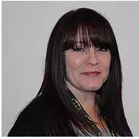

Mrs Brown – PE/COJO teacher (Wed morning) 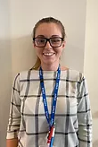

Mrs Watson – FS1 teacher and

Mrs Brady 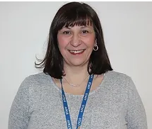 HLTA will also be in the foundation stage unit

There will also be lunchtime staff that will support with lunch.

Mrs Cooke and the before and after school team (if your child attends)

*What a lot of people to love and care for your child!*